


Offered in
Conjunction with

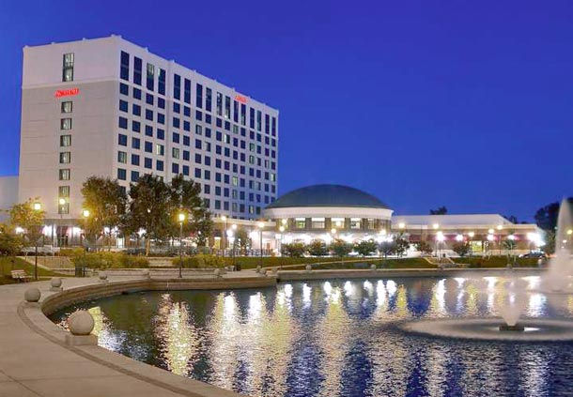

**IMPORTANT DATES**

March 27, 2019
- Hotel Room Reservation Deadline Call 866-329-1758 and mention VACP ensure that you receive the group rate. Or visit the VACP website at www.vapsych.org to reserve your room online.

- Early Bird Registration Deadline *After this date a $25 late fee will apply

April 5, 2019
- Final Postmark date for Registration by mail or fax.
*After this date, bring registration with you to Convention Registration Desk. Late Fee will apply.

April 18-19, 2019
Newport News Marriott at City Center

Spring Convention
& Educational
Conference

Welcome: Creating Space for Everyone in Psychology

Understanding Fees and CE Credits

Va Board of Psychology CE:

- Refers to courses considered eligible for CE credit by Virginia Board of Psychology.

“Ethics” Credit:

Ethics Credit means a course which emphasizes the “ethics, standards of practice or laws governing the profession of psychology.” 1.5 Hours of “Ethics” Credit are required each year for Virginia Board of Psychology licensure renewal.

Fees:

- The general registration (conference) fee, including for student members, is an all-inclusive fee for the conference. Late fees apply to all registrants after March 28th.

CE Verification:

- To obtain CE credit, registrant attend the entire course and have their course card stamped at the conclusion
- Registrant must make sure name and address are clearly printed on their course card.
- At end of course, course monitor must stamp top portion of card. This remains with the registrant as proof of attendance. No additional “certificates” will be mailed.
- No partial credit for any course will be given. To obtain credit you must attend the ENTIRE course. Attendance will be monitored.
- Reprints of CE certificates are available to members at no cost. Non-members must pay $5 per course card for re-prints of CE certificates.

VACP welcomes the Virginia Association for Psychological Science (VAPS) and students of psychology as part of its Spring Conference. Please enjoy student posters and their presentations as noted on the schedule.

Room Reservations at the Newport News Marriott

*VACP has reserved a limited number of sleeping rooms. Make your reservation by March 27, 2019 to ensure availability.

Rate: $125/night
Reservations can be made by dialing 1-866-329-1758
Mention VACP or VIRGINIA ACADEMY OF CLINICAL PSYCHOLOGISTS to ensure that you receive the group rate. Rooms are subject to tax at 14% per room, per day and a $1 per day lodging fee.
(VACP complies with the Americans with Disabilities act. Special assistance request must be received no later than March 27, 2019.)

SAVE THE DATE:

September 21-22, 2019

VACP Fall Symposium

Lansdowne Resort and Spa, Leesburg, VA

Virginia Academy of Clinical Psychologists Conference Registration Sheet

General Conference Registration Required in Order to Attend Any Course or Workshop

$____ $275 VACP Member General Registration
For special dietary needs, please contact the VACP Office no later than March 27, 2019.
(includes all CE functions, meal functions, and social functions)

____ VACP Luncheon and General Membership Meeting
(Free with VACP Member General Registration. Registration required.)

$____ $375 Non-VACP Member General Registration
(to obtain discounted rate, join VACP prior to conference)

$____ $25 Student General Registration (Undergraduate and Post-Graduate)
(Required of all students attending the conference. Registration valid Thursday Only. Does not include any VACP Courses. If student members desire to take courses, register as a VACP Non-Member). VAPS membership is a separate fee that must be paid directly to VAPS.

$____ $75 Virginia Association for Psychological Science Members (VAPS)
(Required of all VAPS members attending the conference. Registration valid Thursday Only. Does not include any VACP Courses. If VAPS members desire to take CE courses, register as a VACP Non-Member)

$____ VPF Voluntary Contribution to the Virginia Psychological Foundation ($25 suggested)

$____ VPLAN Voluntary Contribution to VA Psychologists for Legislative Action Now (VPLAN) ($50 suggested)
(VACP’s Political action committee)

$____ VACP Conference Contribution (Helps VACP subsidize students cost at conference)

$____ LATE FEE-$25 (if Registration is not Postmarked/faxed to VACP office on/before March 27, Students NOT exempt)

**(After April 5, 2019: Registration at the door only, please see the conference registration desk) **

$____ TOTAL- For general conference registration, meals, continuing education presentations and contributions.

Name (As it will appear on your name badge): ___________________________________________________________Degree

Affiliation/School:

Address:

Phone Number: (__________) ______________-____________________ Fax Number: (__________) ______________-

Make Checks Payable to VACP or complete information for payment by MasterCard or Visa

Printed Name on Card MasterCard/Visa (Circle One)

Account Number_________________________________________________________ CVV: _________________Exp. Date: _______________/

Authorized Signature: (Required for Credit Card Charges)

REGISTER ONLINE AT www.vapsych.org or by credit card, MAIL to VACP office or FAX to VACP at 804-643-0311
If registering by check: Send Payment & registration form to: Virginia Academy of Clinical Psychologists
4461 Cox Road, Suite 110
Glen Allen, VA 20360
***************************************************************************************************************************************
(For VACP Office Use Only- Copy to be provided at registration to serve as receipt)

Received From: ______________________________________________________________________________________ Date Received:

Total Amount Received: $___________ Paid by Check #________ OR Paid by Credit Card ____________

Refund Policy: Before March 27th, full refunds will be provided upon written request. Before April 5th, partial refunds will be provided upon written request. After April 5th, no refunds will be provided for any reason.
Wednesday, April 17, 2019
7:00 pm – 10:00 pm VACP Executive Council Dinner Meeting

Thursday, April 18, 2019
7:15 am – 4:00 pm Registration & Exhibits

7:15 am – 8:00 am Continental Breakfast

8:00 am – 12:00 pm Student Papers – Sessions 1 & 2

8:00 am – 9:00 am Lessons Learned in Addressing the Behavioral Health of Refugees from the Middle East
Mona Ezzat-Abuhamda, Psy.D., Private Practice
Objectives:
- Get an understanding of the plight of refugees from the Middle East
- Understand the specific clinical needs of that population
- Work on developing culturally appropriate services
~ Qualifies for 1 Hour CE Credit

9:00 am – 11:00 am An Introduction to Telehealth in Clinical Practice

Corinne Bolander, Psy.D., Hampton Veterans Affairs Medical Center
Jessica Gifford, Psy.D. VA Center for Integrated Healthcare
Janette Mance-Khourey, Ph.D., Hampton Veterans Affairs Medical Center
Telehealth is the use of technology to provide clinical care and education over distance. Telehealth is an effective method for extending the reach of clinical practice, delivering services to the patient in a convenient setting. Various modalities for telehealth will be reviewed, including care provided between patient care sites and into the patient's home.
Objectives:
- Identify different types of telehealth appropriate for use in clinical practice.
- Identify benefits of utilizing telehealth in clinical practice.
- Open discussion of potential opportunities and barriers to implementation for participants.
~ Qualifies for 2 Hours CE Credit
10:00 am – 12:00 pm Student Poster Sessions – Session 1
11:00 am – 12:00 pm Innovative Treatment Strategies for Gambling and other Addictions.
Lyndon J. Aguiar, PhD, LCP, ICGC-I, Williamsville Wellness
William Hoffman, CSAC-A, ICGC-I, Williamsville Wellness
The prevalence of problem gambling in the US is estimated to be just over 2% of the population according to SAMHSA data. We believe this number will dramatically increase as access to sports betting, fantasy sports changes following the SCOTUS ruling this year that struck down a 1992 law that prohibited sports betting outside of Nevada. Of concern in Virginia is the proliferation of casinos on Indian territories and the expansion of parimutuel betting machines at horse tracks. Williamsville Wellness has been providing residential treatment for gambling and substance use disorders for over 10 years. Our team of clinicians are internationally certified gambling counselors and we have developed targeted treatments to effectively help clients address gambling disorders. Attendees will learn how to integrate technology, individual therapy, group therapy, family therapy, and psychological assessments with holistic approaches. Attendees will learn how to mitigate the helplessness that drives the addictive behaviors specific to gambling and implement healthy coping responses that promote wellness and health. We will also review cutting edge tele therapy approaches to treat gambling disorder that we are utilizing at Williamsville Wellness.
~ Qualifies for 1 Hour CE Credit

12:00 pm – 2:00 pm VACP Luncheon and Annual Business Meeting

1:00 pm – 3:00 pm Student Poster Sessions – Session 2

2:00 pm – 4:30 pm Student Paper Sessions 3 & 4

2:00 pm –3:00 pm Psychology and Disaster Mental Health: Responding to Community Violence
Robin Ramsey Telsch, PhD, Disaster Mental Health Volunteer, Virginia Region Lead, ARC
Joanna Yost, PhD, Dept. of Psychiatry & Neurobehavioral Sciences, UVA School of Medicine
Heather Bruschwein, PsyD, Dept. of Psychiatry & Neurobehavioral Sciences, UVA School of Med.
This presentation will explore the psychological factors of community violence and mass casualty events on individuals, institutions, and communities. Topics that will be covered include the impact on first responders and caregivers, how community providers may be affected, roles that psychologists might fill following these events, and available resources and training opportunities. Scenarios will also be provided for discussion.
Objectives:
- Understand and appreciate the psychological factors of community violence and mass casualty events on individuals, institutions, and communities
- Appreciate the impact of human-caused violence on first responders and caregivers
- Recognize various roles psychologists might fill following community violence events
- Identify resources and training opportunities for disaster mental health
~ Qualifies for 1 Hour CE Credit

3:00 pm – 5:00 pm Virginia Board of Psychology Update and Conversation Hour
Virginia Board of Psychology Board Members and Administrative Staff
The first part of this presentation will be an update from members and staff of the Virginia Board of Psychology. Among other issues, they will review (a) The status of proposed revisions to the Board’s regulations, (b) the recently adopted guidance document on “Electronic Communication and Telepsychology” (c) the recently adopted guidance document on “Assessment Titles and Signatures”, (d) the Healthcare Workforce Data Center’s report on “Virginia’s Licensed Clinical Psychologist Workforce: 2018”, (e) the status of the enhanced EPPP, and (f) the status of PSYPACT. Following this overview, the Board will hold a Town Hall meeting by answering questions on topics under their purview from the audience.
Objectives:
- Summarize at least one of the two new Guidance Documents developed by the Board
- Identify at least two contemporary issues being addressed by the Board
~ Qualifies for 2 Hours CE Credit

3:45 pm – 6:30 pm VAPS Meeting

5:30 pm – 6:15 pm VACP Members Reception – (Hotel Lobby Bar. VACP members receive one free drink apiece)

FRIDAY, APRIL 19, 2019
7:30 am – 8:45 am Virginia Psychological Foundation (VPF) Board of Directors Meeting & Breakfast

8:15 am – 9:00 am Continental Breakfast

8:15 am – 11:00 am Registration & Exhibits

9:00 am – 10:00 am The Patchwork Cloak: Intersections of Identity and Suicide Risk
Kimberly Tran, PhD, HSP-P Associate Professor Department of Psychology Fayetteville State University Licensed Psychologist Private Practice
Suicide risk factors vary greatly among several demographic factors such as gender, race/ethnicity and sexual orientation to name a few. When those social identities intersect within the same individual, it can be challenging to discern the factors that increase or conversely protect against suicidal emotions, thoughts and behaviors. This presentation and accompanying discussion will allow participant to:
- Understand the relationships between social identity factors and suicide risk among different groups
- Learn how to navigate and apply the complexities of intersectionality and its positive and negative effects on suicide risk in both research and clinical practice
~ Qualifies for 1 Hour CE Credit
10:00 am – 11:00 am Should I Add Neurofeedback to My Practice? Why? How?
Glenn Weiner, Ph.D. Dominion Behavioral Healthcare of Chesterfield
Neurofeedback, also known as EEG or Brainwave Biofeedback, has been a very helpful approach in the treatment of a broad variety of patients. It can be added very nicely to a traditional assessment and psychotherapy practice. This workshop will present the rationale and research for utilizing Neurofeedback with various disorders (including ADHD; Seizure Disorders; Trauma; Autistic Spectrum Disorders, etc.). We will discuss the practicalities of how clinicians can add this to their practices; financial aspects; and equipment issues. The presenter has been utilizing Neurofeedback in an outpatient practice for the past 18 years and has presented and published on the integration of neurofeedback and psychotherapy. He has found this to be a very helpful tool in working with treatment resistant patients. Sometime will be spent in a live demonstration.
Objectives:
- Participants will learn learn the conceptual model underpinning Neurofeedback and some underlying research for its use.
- Participants will understand how Neurofeedback can be integrated into a psychotherapy practice.
- Participants will learn some of the basic avenues for getting training in this area and some basic information about equipment choices.
~ Qualifies for 1 Hour CE Credit

11:00 am – 12:00 pm Understanding the Cultural Experiences of Immigrant Youth
Alan Meca, Ph.D. Assistant Professor, Old Dominion University
Since the 1970s, the foreign-born population in the United States (US) has rapidly increased, reaching an all-time high of nearly 40 million (13% of the total population) in 2010 (Grieco et al., 2012). Recent estimates place the immigrant population over 42 million (13% of the country’s total population; Brown & Stepler, 2016). Today, the majority of foreign-born individuals residing in the US originate from what is commonly known as the global south (i.e., Latin America and Asia) which typically hold collectivist-based beliefs (i.e., focus on the well-being of the family, clan, nation, or religion), whereas members of the receiving society typically emphasize individualism (i.e., focus on autonomy and self-sufficiency; Hofstede, 2001; Triandis, 1995). The patterns of migration to the US over the past 50 years have therefore produced cultural divides between immigrants and the society that receives them. As a result, scholarly interest on the challenges faced by immigrants has substantially increased over the last few decades (Chirkov, 2009; Schwartz, Unger, Zamboanga, & Szapocznik, 2010). This presentation, drawing on research conducted among Hispanic/Latino immigrants in the last few decades, will explore the challenges faced by immigrant youth within the US. Specifically, this presentation will focus on acculturation, or the extent to which an individual retains his or her cultural heritage and/or adopts the new receiving culture. Additionally, this presentation will discuss the unique cultural stressors experienced by immigrant youth, both first- and second-generation. Finally, given that acculturation occurs within a particular developmental and socio-cultural context, attention will be given to how these processes operate within the context of the family system, the school, the community, and the larger society.
Objectives:
- Understand the dynamic between heritage-culture retention and receiving-culture acquisition among immigrant youth in the United States.
- Understand the cultural stressors experienced by immigrants and the impact they have on psychosocial functioning.
- Contextualize these processes within the family system, the school and community setting, and the larger discourse on immigrants.
~ Qualifies for 1 Hour CE Credit

Parking

On-Site parking: $6.00 daily Valet parking: $12.00 daily

Complimentary off-site parking Electric car charging stations: 1, complimentary

Driving Directions
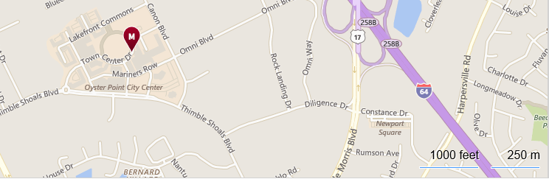
- Take I-64 East towards Norfolk/Virginia Beach
- Take EXIT 258A - US-17 S / J Clyde Morris Blvd
- Merge onto J Clyde Morris Blvd
- Turn right at first traffic light onto Diligence Drive
- At dead end, turn right onto Thimble Shoals Blvd
- Turn right at first traffic light onto Canon Blvd
- Take second left onto Town Center Drive
- Newport News Marriott at City Center,
740 TOWN CENTER DRIVE is on the left.

Newport News City Center Activity Guide
Restaurants / Cafes / Specialty Foods

- Aromas Specialty Coffees & Bakeshop
- Boathouse Live
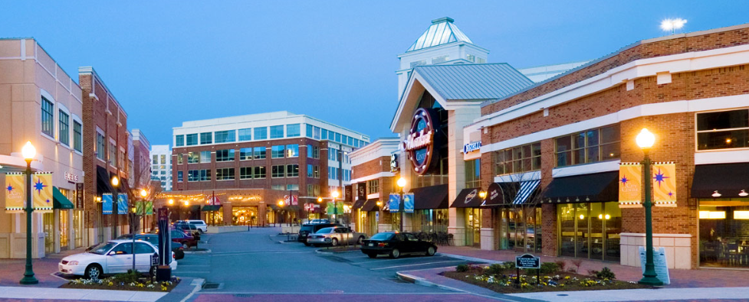
- Café 111
- City Center Ice Cream
- Cove Tavern
- Hayashi Japanese Steakhouse & Sushi
- Juicing Life Bar
- MyPi Pizza - Custom Pizza, Craft Beer
- Neo Kitchen and Bar
- Salad Creations
- Salsa's Mexican Restaurant
- TASTE
- Tucanos Brazilian Grill

Apparel & Accessories/ Entertainment/ Home Furnishings/ Specialty Services

- Ann Taylor Loft
- Anointed Life
- Hauser's Jewelers
- The Perfect Setting / Ritzy Kids
- Cinemark City Center 12
- Board & Brush
- Animare Salon & Spa - Aveda
- Colonial Computers
- D. Alan's Color Splash
- EZ-Vest Realty Inc.
- Luxury Tress Salon & Extension Bar
- Onelife Fitness
- Wine & Design

Welcome from Dr. Thorayya Said Giovannelli
VACP Conference Chair

Please join us for VACP's Spring Conference, which is scheduled for April 18th and 19th, 2019, at the Newport News Marriott at City Center. The theme of the 2019 conference is the creation of welcoming spaces for all within psychology. Our field, our Commonwealth and our nation continue to become more and more diverse, and your VACP is here to help you be prepared for these changes. I sincerely hope that you will leave this conference with increased awareness and competencies for working in new, exciting domains. We are excited to have an excellent slate of presenters, including speakers on incorporating tele-mental health into practice. And as always, there will be plenty of time for networking and connecting with peers over the two days. A heartfelt thank you to all of our speakers, to the VACP staff and to our board members for making this conference possible. I hope to see you there.





4461 Cox Road, Suite 110
Glen Allen, VA 23060

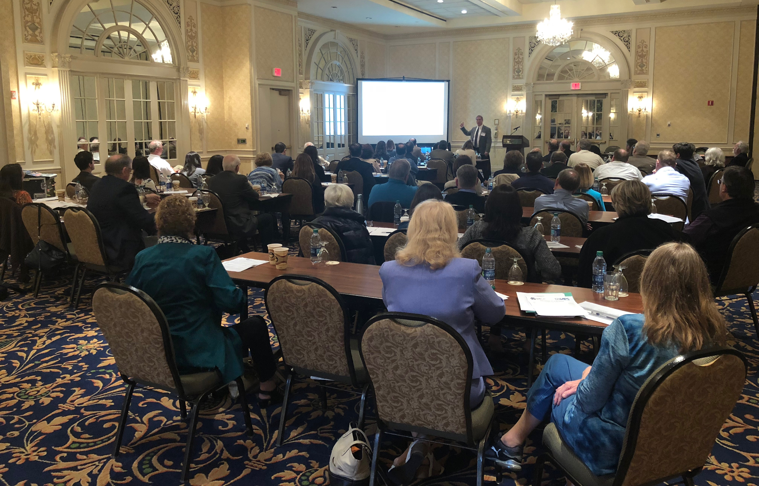
Virginia Academy of Clinical Psychologists (VACP)

is the voice of professional clinical psychology within the Commonwealth of Virginia. Its purpose is "the advancement of Clinical Psychology as a science, as a profession, and as a means of promoting human welfare by developing and encouraging high standards of ethics and training; by providing the opportunity for the exchange of experience and research through discussions, presentation and publications; and by educating the public in the purposes and goals of the art and science of the practice of clinical psychology for the promotion of the public welfare."

